Parents: Accessing Student Grades
Infinite Campus Portal
Rockdale County Public Schools

You can monitor up-to-date grades for your student at any time through the Parent Portal. Please read the directions below carefully to learn more.

- Log on to your Parent Portal account through rockdaleschools.org/infinitecampus
- If you have more than one student in your account, select a student using the drop-down list at the top of the screen.
- Click the “Grades” link in the left menu.
- You will see your child’s grades listed here.

IMPORTANT: Grades highlighted in YELLOW are the current, up-to-date averages. These will change as your child’s average changes. Grades highlighted in GREEN are the grades at the time of progress reports. These will not change.

- Click on the name of a class to see details about the individual assignments and grades that make up the average.

Note: To see archived report cards/progress reports, you can also click on the “Reports” link in the left menu. This will give you access to print-friendly grade reports in PDF format (Adobe Reader required.)

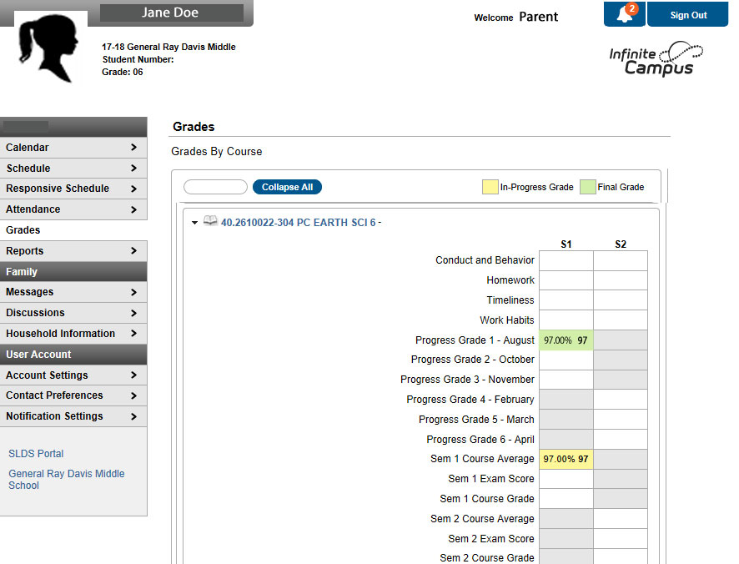
Select your student

Click the “Grades” link here
Yellow boxes show the current average.
Green boxes show grades at the time of progress reporting

